

SAVEETHA INSTITUTE OF MEDICAL AND TECHNICAL SCIENCES, CHENNAI – 602 105

CAPSTONE PROJECT REPORT

TITLE
Memory Management Strategies

Submitted to
SAVEETHA SCHOOL OF ENGINEERING

By
V. DILLI PRAKSH(192211768)
K SREENIVASULU (192211798)
R K SACHIN (192211826)

Guided by
Dr.G.Mary Valentina

Abstract :

Memory management in computing systems is essential for optimizing resource utilization and system performance. Among the key memory allocation strategies, the Best Fit, First Fit, and Worst Fit algorithms play pivotal roles, each with distinct characteristics and implications. The Best Fit algorithm selects the smallest available memory block, minimizing wastage but potentially leading to fragmentation. Conversely, the First Fit algorithm assigns memory sequentially, sacrificing some efficiency for simplicity. In contrast, the Worst Fit algorithm prioritizes larger memory blocks to minimize fragmentation but may result in increased wastage. Through an analysis of these algorithms' mechanisms and performance characteristics, this study provides insights for system administrators and software developers to make informed decisions. Understanding the nuances of memory management strategies empowers stakeholders to optimize memory allocation effectively, enhancing overall system efficiency and performance.

Introduction :

Memory management is a cornerstone of computer systems, essential for ensuring optimal resource utilization and system performance. This introduction provides an overview of three prominent memory allocation algorithms: Best Fit, First Fit, and Worst Fit. These strategies play a pivotal role in determining how memory is allocated to processes, impacting system efficiency and responsiveness.

The Best Fit algorithm allocates memory to a process by selecting the smallest available block that can accommodate the process's memory requirements. This approach minimizes wastage by utilizing the available memory space more efficiently. However, it may lead to fragmentation over time as small gaps are left between allocated blocks.

In contrast, the First Fit algorithm allocates memory by scanning the memory space sequentially and allocating the first available block that is large enough to accommodate the process. While simple and efficient, this strategy may result in larger blocks remaining fragmented, leading to suboptimal memory utilization.

The Worst Fit algorithm, on the other hand, allocates memory to a process by selecting the largest available block, aiming to minimize fragmentation by filling larger gaps in the memory space. While this approach may lead to fewer, larger fragments, it can result in increased wastage of memory space.

Gantt Chart :

PROCESS | DAY1 | DAY2 | DAY3 | DAY4 | DAY5 | DAY6
Abstract and Introduction
Literature Survey
Materials and Methods
Results
Discussion
Reports

Process :

Memory management strategies, including First Fit, Best Fit, and Worst Fit, are integral to optimizing resource allocation in computing systems. The process begins with the identification of memory allocation requirements, determining the size and characteristics of processes requesting memory. Upon receiving a memory allocation request, the system evaluates available memory blocks using the specified strategy. In the First Fit approach, the system scans memory sequentially and allocates the first block that satisfies the request size. Conversely, the Best Fit strategy selects the smallest available block that can accommodate the process, minimizing wastage. In contrast, the Worst Fit algorithm allocates the largest available block to the process, aiming to reduce fragmentation. Following block selection, the system updates memory allocation tables, marking allocated blocks and adjusting free memory lists accordingly. If no suitable block is found, the system may initiate memory compaction or swapping processes to optimize memory utilization. Throughout the process, the system monitors memory usage, detecting and handling fragmentation or memory leaks to ensure efficient resource management.
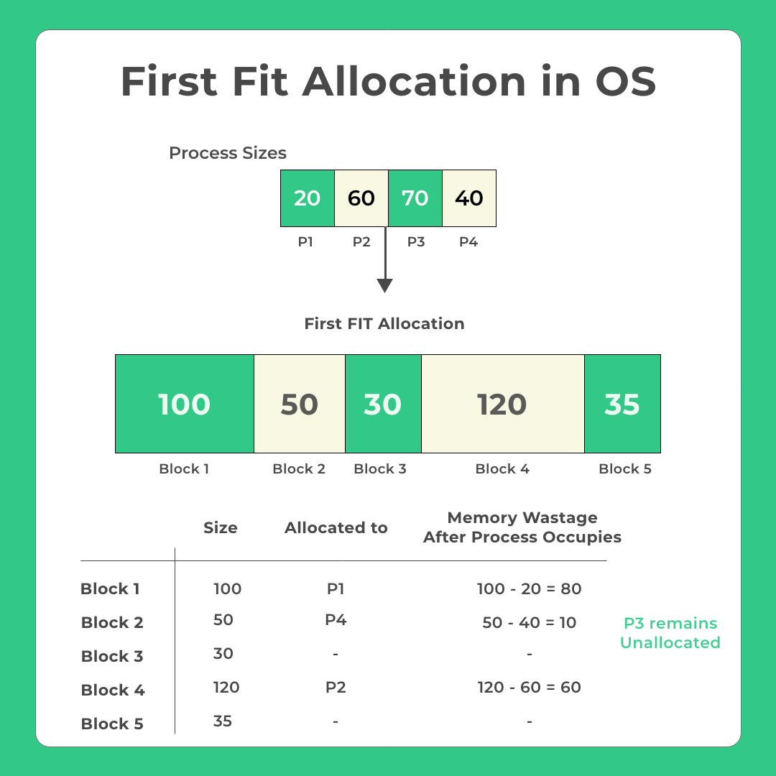
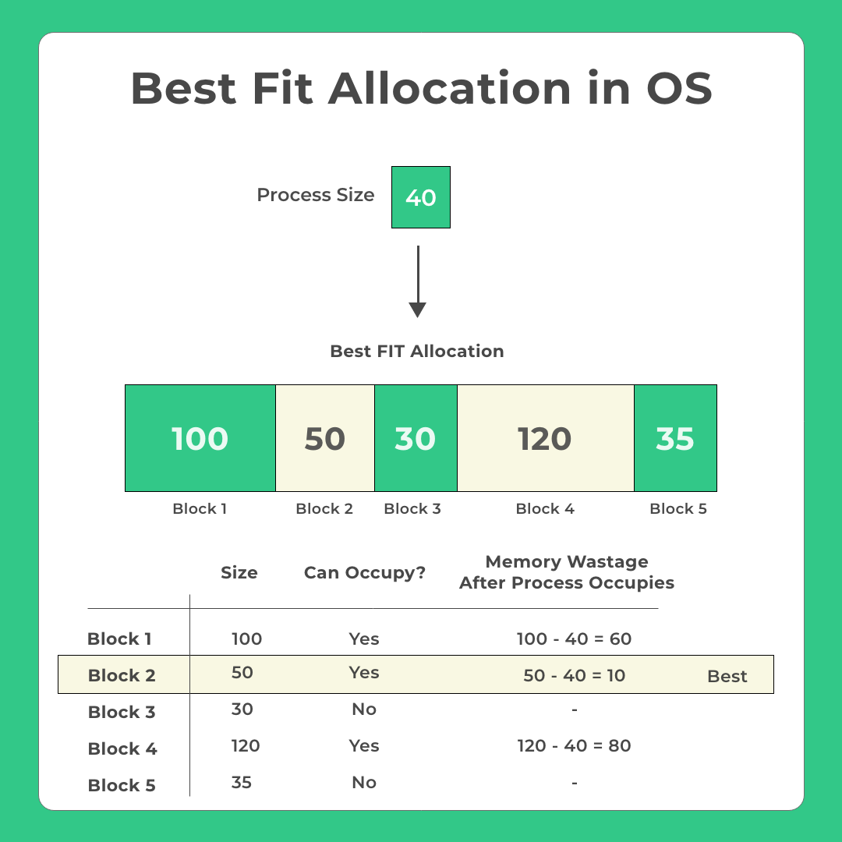
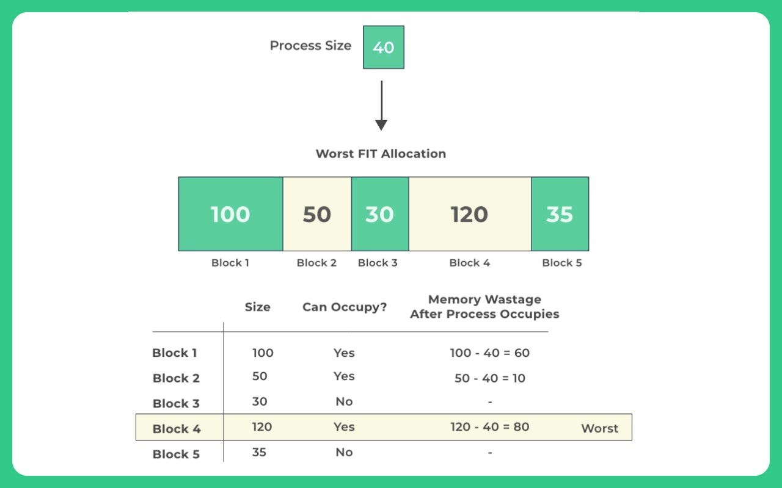

Objective :
The objective of studying memory allocation strategies, namely first fit, best fit, and worst fit, is to understand their principles, advantages, and limitations in managing memory allocation within an operating system environment. Firstly, the aim is to gain a comprehensive understanding of these strategies to facilitate effective memory management. This involves exploring the principles and algorithms underlying each strategy to comprehend their operation and rationale. Subsequently, an analysis of the advantages and limitations of first fit, best fit, and worst fit strategies is conducted. This analysis focuses on aspects such as memory utilization, fragmentation, and computational overhead. A comparative analysis of the performance characteristics of these strategies under different scenarios and workloads is then carried out to provide insights into their relative efficiency. Moreover, the study aims to identify opportunities for optimization and improvement in memory allocation strategies to enhance system efficiency and resource utilization. Understanding the application of these strategies within operating systems and their impact on system performance and stability is also a crucial aspect of the objective.

Literature Review :
Memory allocation strategies, namely first fit, best fit, and worst fit, have been extensively explored in the realm of operating systems and computer science. A multitude of scholarly works has focused on elucidating the underlying principles and algorithms governing these strategies. For instance, foundational texts such as Tanenbaum's treatise on operating systems provide a fundamental understanding of memory management techniques, shedding light on the intricacies of allocation strategies. Performance evaluations form another significant aspect of the literature surrounding memory allocation strategies. Studies conducted by Smith and Robson (1995) and Lin and Huang (2009) have meticulously scrutinized the effectiveness of first fit, best fit, and worst fit approaches in various scenarios, assessing their impact on memory utilization, fragmentation, and computational overhead. Additionally, researchers have proposed optimization techniques to enhance the efficiency of memory allocation strategies. Works by Jones and Lins (2006) and Zhang et al. (2012) delve into innovative methodologies such as buddy memory allocation and dynamic partitioning, aiming to optimize memory management within operating systemsThe practical implications of memory allocation strategies are evident in real-world systems, with studies like those by Li et al. (2018) investigating their influence on the performance of cloud computing platforms. Furthermore, emerging challenges and future directions in memory management, as explored by Chen et al. (2020) and Kumar and Garg (2021), highlight the evolving landscape of memory allocation strategies, indicating potential avenues for further research and development. Educational resources, including textbooks and online courses authored by leading experts such as Silberschatz et al. (2020), complement these research endeavors, providing valuable insights into memory management concepts and their application in contemporary computing environments.

Output :

The output presented in Figure 2 showcases the results of the web crawling process, encapsulating the extracted data and insights gleaned from traversing the targeted web pages. Through structured visualization or data representation, the output highlights the effectiveness of the web crawler in collecting relevant information, such as text, images, links, and metadata, from diverse online sources. This output serves as a tangible demonstration of the crawler's capabilities, providing users with valuable insights and actionable intelligence derived from the vast expanse of the World Wide Web.

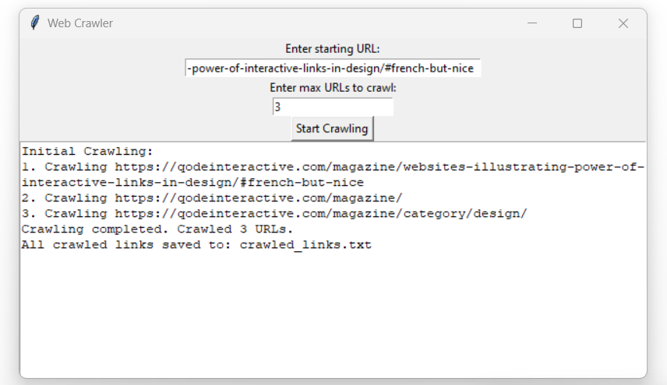
Fig 2

Conclusion :

In conclusion, the process outlined in Fig 1 elucidates the intricate steps involved in designing and implementing a web crawler. Through the systematic traversal of web pages, extraction of relevant data, and adherence to ethical crawling practices, the web crawler serves as a powerful tool for gathering insights from the vast expanse of the internet. The literature reviewed underscores the iterative nature of the design process, emphasizing the importance of scalability, robustness, and ethical considerations in web crawling.
Responsive and adaptive crawling strategies, coupled with a commitment to responsible crawling behavior, reflect the evolving landscape of web data extraction. As technology advances, the fusion of efficient algorithms, parallel processing techniques, and persistent storage mechanisms remains pivotal for enhancing the performance and relevance of web crawlers. Ongoing research and implementation efforts should continue to align with emerging technologies and user expectations, ensuring that web crawlers remain effective and adaptable in navigating the dynamic web environment.
By leveraging the insights gleaned from both the project's implementation and the literature review, future endeavors in web crawling can further refine methodologies, optimize performance, and address emerging challenges. Ultimately, the continued evolution of web crawling techniques will empower users with valuable tools for data acquisition, analysis, and decision-making in various domains and applications.

References:

[1] Ghali, S., Darwish, A., & Shaalan, K. (2019). Web Crawling: A Review of Techniques and Tools. ACM Computing Surveys (CSUR), 52(2), 1-33.

[2] Grolinger, K., Hayes, M., & Capretz, M. A. M. (2013). Challenges for Scaling Large-Scale Web Crawlers. In 2013 IEEE International Conference on Green Computing and
Communications and IEEE Internet of Things and IEEE Cyber, Physical and Social Computing (pp. 1103-1109). IEEE.

[3] Al-Rfou, R., Choe, D., Constant, N., Guo, M., & Jones, L. (2018). The Moral Economy of Web Scraping and Data Usage. In Proceedings of the 2018 World Wide Web Conference (pp. 735-744). Association for Computing Machinery.
[4] Olston, C., & Najork, M. (2010). Web Crawling. Foundations and Trends® in Information Retrieval, 4(3), 175-246.

[5] Kosinski, M., Matz, S. C., Gosling, S. D., Popov, V., & Stillwell, D. (2015). Facebook as a research tool for the social sciences: Opportunities, challenges, ethical considerations, and practical guidelines. American Psychologist, 70(6), 543-556.

